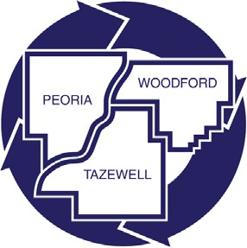
Tri-County Regional Planning Commission
EST. 1958

PERSONNEL COMMITTEE
456 Fulton, Suite 401
Peoria, IL 61602
DANNY PHELAN, CHAIRMAN
Greg Menold, Autum Jones
Monday October 20, 2025
8:00 a.m.

AGENDA

- Call to Order

- Roll Call

- Motion to approve May 7, 2025 minutes

- Recommendation to Executive Committee and Full Commission Employee Promotions in Place (Resolution 26-19) memo attached

- Discussion of Executive Director Performance Evaluation Process Timeline

- Executive Session if needed

- Other

- Adjournment

